## 4.Locked Profile

In this problem, you must **create a JS program** which **shows** and **hides** the additional information about users, which you can find by making a GET request to the server at address:

http://localhost:3030/jsonstore/advanced/profiles

The response will be an object with the information for all users. Create a profile card for every user and display it on the web page. Every item should have the following structure:

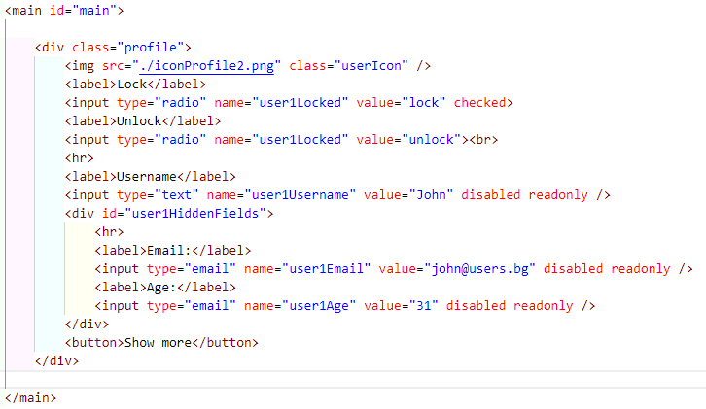

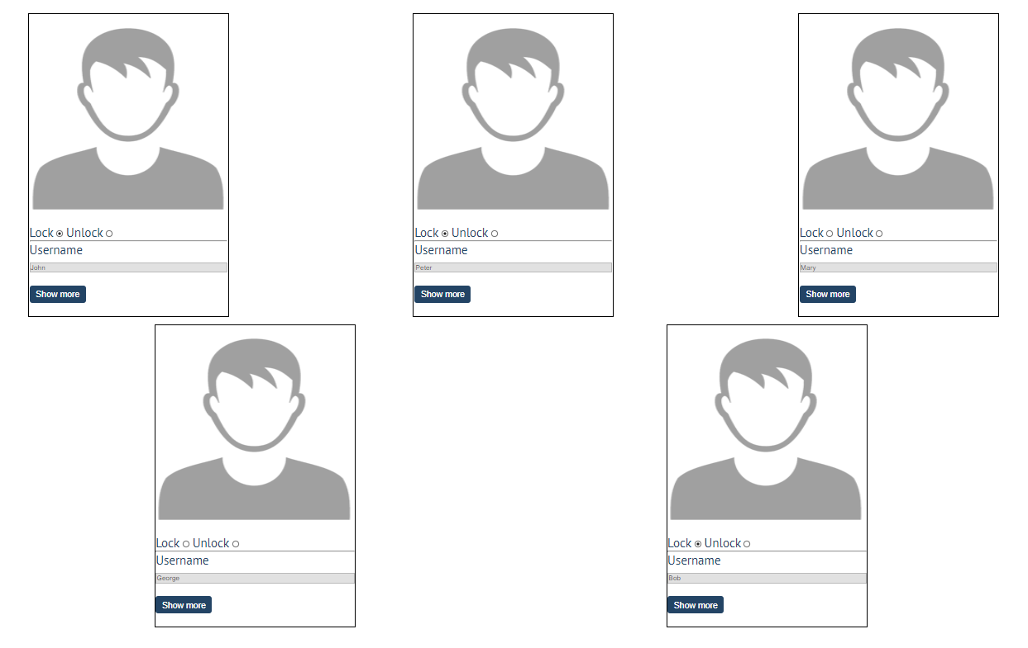

When one of the [**Show more**] **buttons** is clicked, the **hiden information** inside the div should be shown, only if **the profile is not locked**! If the current profile is **locked,** nothing should happen.

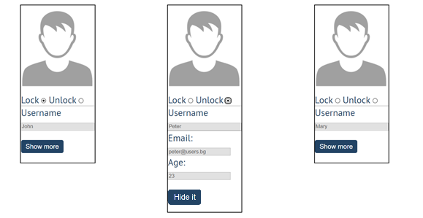

If the **hidden information is displayed** and we **lock** **the profile again**, the [**Hide it**] button should **not be working**! Otherwise, when the profile is **unlocked** and we click on the **[Hide it]** button, the new fields